SUPPLEMENTARY METHODS

Patient cohorts
The HCC patients who provided samples for the cDNA microarrays and tissue microarrays were derived from two independent cohorts established in our department between 2012 to 2017. The HCC patients who provided fresh samples for CyTOF confirmation assay were enrolled in our department between February 2019 and April 2019. All patients were diagnosed, treated, and followed up in our department.
Single-cell transcriptome analysis by microwell-seq
Tumor tissue was cut into pieces using scissors and digested into single cells using Collagenase IV. Dead cells were removed using density gradient centrifugation, and living cells were applied to a microwell plate. Cells were treated and transcriptome data were obtained as previously described(1).
Whole exome sequencing (WES)
DNA was extracted from tissues using the DNeasy Blood & Tissue Kit (Qiagen, Venlo, Limburg, The Netherlands) following the manufacturer’s recommendations. The quality of isolated genomic DNA was quantified and verified by Qubit® DNA Assay Kit in Qubit® 2.0 Flurometer (Invitrogen, Carlsbad, CA, USA) and agarose gel electrophoresis. Sequencing libraries were generated using Agilent SureSelect Human All Exon Kit (Agilent Technologies, Santa Clara, CA, USA) following manufacturer’s instructions. After capture and enrichment with index tags, products were purified and quantified using AMPure XP system (Beckman Coulter, Beverly, MA, USA) and the Agilent high sensitivity DNA assay on the Agilent Bioanalyzer 2100 system. The cluster generation was performed according to the manufacturer’s instructions on a cBot Cluster Generation System using Hiseq PE Cluster Kit (Illumina, San Diego, CA, USA). The DNA libraries were sequenced on an Illumina Hiseq XTEN platform. After basis quality control processing, high quality clean data was mapped to the reference human genome (UCSC hg19) by Burrows-Wheeler Aligner software(2).

RNA-seq
After extraction, total RNA purity was checked using the NanoPhotometer® spectrophotometer (IMPLEN, Westlake Village, CA, USA). mRNA was isolated by Oligo Magnetic Beads and cut into small fragments for cDNA synthesis. Libraries were generated using the NEBNext UltraTM RNA Library Prep Kit for the Illumina system (New England Biolabs, Ipswich, MA, USA) following the manufacturer’s instructions and index codes were added to attribute sequences to each sample. After cluster generation, the library preparations were sequenced on an Illumina Hiseq XTEN platform. Raw data were processed through quality control step to obtain clean data with high quality. After reads mapping, HTSeq was used to count the reads numbers mapped to each gene. Then FPKM was calculated based on gene length and reads count mapped to this gene.

Quantitative proteomics by multiplexed tandem mass tag (TMT) MS
The samples were individually milled into power and lysed in a buffer that consisted of Tris-base (pH 8), 8M Urea, 1% SDS and protease inhibitors (Sigma-Aldrich, Saint Louis, MO, USA) for 20 min. The lysates were centrifuged at 12000 g for 15 min at 4°C and the protein concentration was determined with a Bradford assay. Proteins were then reduced with 10 mM DTT and subsequently alkylated with iodoacetamide for 1 hour at room temperature in the dark. Afterwards, the extract was digested with trypsin (Promega, Madison, WI, USA) at 37°C for 16 h. Then peptide was desalted with C18 cartridge to remove the high urea. Desalted peptides were labeled with TMT10-plex reagents (TMT10plex™ Isobaric Label Reagent Set, Thermo Fisher Scientific, Waltham, MA, USA), following the manufacturer’s instructions. Differently labeled peptides were mixed equally, desalted by peptide desalting spin columns (89852, Thermo Fisher Scientific), and then fractionated using a C18 column (Waters BEH C18 4.6×250 mm, 5 μm) on a Rigol L3000 HPLC operating at 1 mL/min, the column oven was set as 50°C. Mobile phases A (2% acetonitrile, adjusted pH to 10.0 using ammonium hydroxide) and B (98% acetonitrile, adjusted pH to 10.0 using ammonium hydroxide) were used to develop a gradient elution. The solvent gradient was set as follows: 3% B, 5min; 3-8% B, 0.1 min; 8-18% B, 11.9 min; 18-32% B, 11 min; 32-45% B, 7 min; 45-80% B, 3 min; 80% B, 5 min; 80-5%, 0.1 min; 5% B, 6.9 min. The eluates were monitored at UV 214 nm, collected for a tube per minute and merged into 15 fractions finally. All fractions were dried under vacuum and reconstituted in 0.1% (v/v) formic acid (FA) for subsequent liquid chromatography tandem mass spectrometry (LC-MS/MS) analysis.
Proteomics analyses were performed using an EASY-nLCTM 1200 UHPLC system (Thermo Fisher Scientific) coupled to an Orbitrap Q Exactive HF-X mass spectrometer (Thermo Fisher Scientific) by Novogene (Beijing, China). Briefly, the samples were redissolved in 0.1% (v/v) formic acid (FA), and injected onto an Acclaim PepMap100 C18 Nano-Trap column (2 cm×100 μm, 5 μm) and then separated by Reprosil-Pur 120 C18-AQ analytical column (15 cm×150 μm, 1.9 μm) with a linear gradient from 5 to 100% of eluent B (0.1% FA in 80% ACN) in eluent A (0.1% FA in H2O) in 120 min at a flow rate of 600 nL/min. The corresponding detailed solvent gradient listed as follows: 5-10% B, 2 min; 10-40% B, 105 min; 40–50% B, 5 min; 50–90% B, 3 min; 90–100% B, 5 min. A data-dependent strategy was used by measuring MS1 in the Orbitrap at a resolution of 60,000 and the top 40 precursor ions from full MS scan were selected for fragmentation using higher energy collisional dissociation (HCD) at a resolution of 45000 with 32% of normalized collision energy and 60 s of dynamic exclusion time.
Protein identification and quantification were performed based on the Uniprot human database by the search engines: Proteome Discoverer 2.2 (Thermo Fisher Scientific). The searched parameters as follows: A mass tolerance of 10 ppm for precursor ion scans and a mass tolerance of 0.02 Da for the product ion scans were used. Carbamidomethyl was specified in PD 2.2 as fixed modifications. Oxidation of methionine, acetylation of the N-terminus and TMT 10-plex of lysine were specified in PD 2.2 as variable modifications. A maximum of 2 miscleavage sites were allowed. For protein identification, protein with at least 1 unique peptide was identified at FDR less than 1.0%. The protein quantitation results were statistically analyzed by Mann-Whitney Test, the significant ratios, defined as p < 0.05 and fold change > 1.5 or <0.67 were used to screen the differentially expressed proteins and then perform the functional enrichment analysis of Gene Ontology (GO) and Kyoto Encyclopedia of Genes and Genomes (KEGG).
Untargeted metabolomics by liquid chromatography(LC)-MS/MS
Tissues were individually grounded with liquid nitrogen and 100 μL of the homogenates was resuspend with precooled 100 % methanol (-20℃) followed by well vortexing. The samples were incubated at -20 °C for 60 min and then were centrifuged at 14000 g, 4°C for 15 min. Then the supernatants were transferred to a fresh microcentrifuge tube and dried under vacuum in a centrifugal evaporator. The dried metabolite pellets were redissolved by 80% methanol and analyzed by LC-MS/MS. LC-MS/MS analyses were performed using a Vanquish UHPLC system (Thermo Fisher Scientific) coupled with an Orbitrap Q Exactive HF-X mass spectrometer (Thermo Fisher Scientific) by Novogene. Samples were injected onto an Accucore HILIC column (100×2.1 mm, 2.6 μm) using a 20-min linear gradient at a flow rate of 0.3 mL/min. The eluents of the positive polarity mode were eluent A (0.1% FA in 95% ACN, 10 mM ammonium acetate) and eluent B (0.1% FA in 95% ACN, 10 mM ammonium acetate). The eluents of the negative polarity mode were eluent A (95% ACN, 10 mM ammonium acetate, pH 9.0) and eluent B (50% ACN, 10 mM ammonium acetate, pH 9.0). The solvent gradient was set as follows: 2% B, 1 min; 2-50% B, 16.5 min; 50-2% B, 2.5 min. Q-Exactive HF-X mass spectrometer was operated in positive/negative polarity mode with spray voltage of 3.2 kV, capillary temperature of 320°C, sheath gas flow rate of 35 arb and aux gas flow rate of 10 arb.
Identification and quantification of metabolites were performed using the mzCloud database by the search engines: Compound Discoverer 3.0 (Thermo Fisher Scientific). Differentially expressed metabolites were screened based on VIP value from PLS-DA analysis and P value from t-test (VIP > 1 and P value < 0.05).
Immunohistochemistry
Immunohistochemistry were conducted as previously described(3). Anti-CD45 and anti-Foxp3 antibodies were purchased from Servicebio (GB14038, Wuhan, China) and Abcam (ab20034, Cambridge, UK), respectively. Secondary antibodies and detection system were purchased from DaKo (K5007, Glostrup, Denmark). The density of positive cells was manually calculated using five randomly chosen fields.

Quantitative polymerase chain reaction (qPCR)
Total RNA was extracted from frozen HCC samples resected in our department in the past five years and used for cDNA generation by reverse transcription. All cDNA samples were aliquoted in 384-well plates in triplicate to generate an in-house HCC cDNA microarray. qPCR assays were performed as previously described(3). The primers of PTPRC (forward: 5’-TATTTGTGACAGGGCAAAGC-3’, reverse: 5’-CACTTGAAAGTGGAACACTGG-3’), FOXP3 (5’- AGCACATTCCCAGAGTTCCTC -3’, reverse: 5’-CGTGTGAACCAGTGGTAGATC-3’), and GAPDH (5’-AACAGCAACTCCCATTCTTC-3’, reverse: 5’- TGGTCCAGGGTTTCTTACTC-3’) were generated by XY Biotechnology (Hangzhou, China).
Bioinformatic analysis
For whole-exome sequencing, the single nucleotide variations (SNVs), insertions and deletions (INDELs), and copy number variations were detected as described previously(4-6). For RNA sequencing, reads were mapped to the reference genome using Hisat2 v2.0.5 after quality control processing. The fragments per kilobase of transcript per million mapped reads (FPKM) were used to evaluate the expression levels of genes. Differential expression analysis was performed using the edgeR package(7). Function enrichment analysis of differentially expressed genes or proteins was implemented by the R package clusterProfiler(8), including GO and KEGG pathway analysis. For the multi-block integration assessment, the first components from each omic data set was extracted for further correlation analysis in R package mixOmics.
For the integration mapping, differential expression analysis for each nodule was performed using GFold with corresponding normal tissue from the same patient(9). Differentially expressed genes were selected with expression fold change cutoff of 2. Somatic mutations and differentially expressed genes were enriched to KEGG pathways using R package clusterProfiler. Parameters including p-value cutoff, q-value cutoff, and minGSSize were set to 1 in order to get all KEGG pathways overlapping with our interested gene list. Differential metabolites set over-representation analysis were performed using ConsensusPathDB with minimum overlap number set to 1 and p-value cutoff to 1(10). For each KEGG pathways, the enrichment ratio respecting somatic mutations, RNAseq, and metabolites was defined as proportions of overlapping genes in all genes/compounds for a certain pathway. Only pathways with at least one q-value < 0.05 was selected for subsequent analysis. For each entry, the enrichment ratio was scaled by (x - mean(x)) / (max(x) - min(x)). For each nodule, the final enrichment score was defined as mean value of somatic mutation, RNAseq, and metabolism. Pathways with standard deviation > 0.05 across all nodules were identified.

SUPPLEMENTARY REFERENCES

1 Han X, Wang R, Zhou Y, Fei L, Sun H, Lai S, et al. Mapping the mouse cell atlas by microwell-seq. Cell 2018;172:1091-1107.
2 Li H, Durbin R. Fast and accurate short read alignment with Burrows-Wheeler transform. Bioinformatics 2009;25:1754-1760.
3 Zhang Q, Bai X, Chen W, Ma T, Hu Q, Liang C, et al. Wnt/beta-catenin signaling enhances hypoxia-induced epithelial-mesenchymal transition in hepatocellular carcinoma via crosstalk with hif-1alpha signaling. Carcinogenesis 2013;34:962-973.
4 Cibulskis K, Lawrence MS, Carter SL, Sivachenko A, Jaffe D, Sougnez C, et al. Sensitive detection of somatic point mutations in impure and heterogeneous cancer samples. Nature biotechnology 2013;31:213-219.
5 Saunders CT, Wong WS, Swamy S, Becq J, Murray LJ, Cheetham RK. Strelka: accurate somatic small-variant calling from sequenced tumor-normal sample pairs. Bioinformatics 2012;28:1811-1817.
6 Boeva V, Popova T, Bleakley K, Chiche P, Cappo J, Schleiermacher G, et al. Control-FREEC: a tool for assessing copy number and allelic content using next-generation sequencing data. Bioinformatics 2012;28:423-425.
7 Robinson MD, McCarthy DJ, Smyth GK. edgeR: a Bioconductor package for differential expression analysis of digital gene expression data. Bioinformatics 2010;26:139-140.
8 Yu G, Wang LG, Han Y, He QY. clusterProfiler: an R package for comparing biological themes among gene clusters. OMICS 2012;16, 284-287.
9 Feng J, Meyer CA, Wang Q, Liu JS, Shirley Liu X, Zhang Y. GFOLD: a generalized fold change for ranking differentially expressed genes from RNA-seq data. Bioinformatics 2012;28, 2782-2788.
10 Kamburov A, Pentchev K, Galicka H, Wierling C, Lehrach H, herwig R. ConsensusPathDB: toward a more complete picture of cell biology. Nucleic Acids Res 2011;39, D712-717.

SUPPLEMENTARY TABLES

Table S1 Antibodies used for CyTOF assays (see additional Excel file)

Table S2 Clinical and demographic information of HCC patients involved in the study
Parameters | Patient 1 | Patient 2 | Patient 3 | Patient 4 | Patient 5 | Patient 6 | Patient 7 | Patient 8
Age (year) | 64 | 51 | 43 | 49 | 71 | 55 | 69 | 48
Gender | M | M | F | M | M | M | M | M
Tumor size (cm) | 12 × 14 | 10 × 7 | 18 × 10 | 12 × 11 | 4 × 4 | 5 × 5 | 5 × 5 | 6 × 5
Tumor location | S7/8 | S7/8 | S4/8 | S6/7 | S5/8 | S7 | S6/7 | S7/8
Nodule number | 9 | 4 | 2 | 1 | 1 | 1 | 1 | 1
Sample number | 12 | 7 | 10 | 4 | 2 | 2 | 2 | 3
Differentiation* | low, median, high | median | median | median | median | median | median | median
TMN staging | T2bN0M0,  II | T2bN0M0, II | T2bN0M0, II | T2bN0M0, II | T2bN0M0, II | T2bN0M0, II | T2bN0M0, II | T2bN0M0, II
Pathological grading | I-III | II | II | II | II | III | III | III
MVI grading | M1 | M1 | M1 | M1 | M1 | M1 | M0 | M1
Barcelona classification | A | A | A | A | A | A | A | A
ICG R15 | 9.5% | 4.6% | 4.1% | 2.8% | 9.1% | 4.0% | 9.3% | 0.6%
ALT (U/L) | 43 | 61 | 32 | 50 | 18 | 51 | 28 | 65
AST (U/L) | 71 | 80 | 45 | 106 | 23 | 41 | 26 | 51
AFP (ng/mL) | > 20000 | 3.3 | > 20000 | 48 | 2 | 6 | 4.4 | 119.1
HBsAg | + | + | + | + | + | + | + | +
HBeAg | - | - | - | - | - | - | - | -
HBeAb | + | + | + | + | + | + | + | +
HBcAb | + | + | + | + | + | + | + | +
HBV DNA (IU/mL) | 3.59 × 10⁴ | 1.59 × 10³ | 8.02 × 10³ | 9.04 × 10⁴ | < 30 | 1.69 × 10⁵ | 4.61 × 10⁵ | 4.23 × 10⁴
Others | Hepatic schistosomisasis, cirrhosis | Cirrhosis | With tumor thrombosis | Pulmonary tuberculosis | Cirrhosis | Liver steatosis | Cirrhosis | Cirrhosis
MVI: microvascular invasion.
*Different nodules may show different differentiations.

Table S3 Clinical and demographic information of HCC patients of the CyTOF confirmation cohort (see additional Excel file)

Table S4 Characteristic of patients in different subtypes tested in an HCC cohort
Subtype |  |  | 1  (n = 33) | 2  (n = 65) | 3  (n = 35) | P value*
Age |  | Median (range) | 59 (17-74) | 58 (31-78) | 61 (25-85) | 0.955
Gender |  | Male (%) | 30 (90.9) | 54 (83.1) | 31 (88.6) | 0.515
 |  | Female (%) | 3 (9.1) | 11 (16.9) | 4 (11.4)
HBV infection |  | Yes (%) | 21 (63.6) | 41 (63.1) | 24 (68.6) | 0.852
 |  | No (%) | 12 (36.4) | 24 (36.9) | 11 (31.4)
Alcohol use |  | Yes (%) | 13 (39.4) | 26 (40.0) | 17 (48.6) | 0.664
 |  | No (%) | 20 (60.6) | 39 (60.0) | 18 (51.4)
Tumor differentiation** |  | Well (%) | 7 (26.9) | 3 (5.0) | 3 (9.7) | 0.000
 |  | Moderate (%) | 15 (61.5) | 35 (58.3) | 14 (45.2)
 |  | Poor (%) | 4 (19.2) | 22 (36.7) | 14 (45.2)
*, P value was calculated using chi-squared test to compare the differences among subtypes 1, 2, and 3.
**, The pathological grade of 21 tumor samples were uncertain.
SUPPLEMENTARY FIGURES

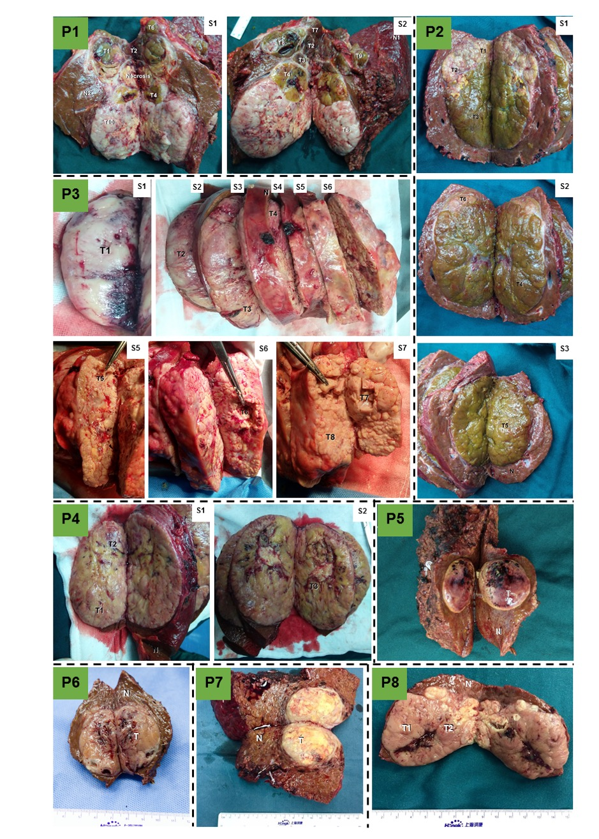
Figure S1 Gross examination of sampling. Pictures showing the location that each sample was obtained from the eight patients. Each tumor had a complete encapsulation, and each lesion had a relatively clear margin. In Patients 1-3, obviously distinct appearance was seen. S denotes tumor layer as cut by a surgical knife, T denotes tumor, N denotes normal tissue.

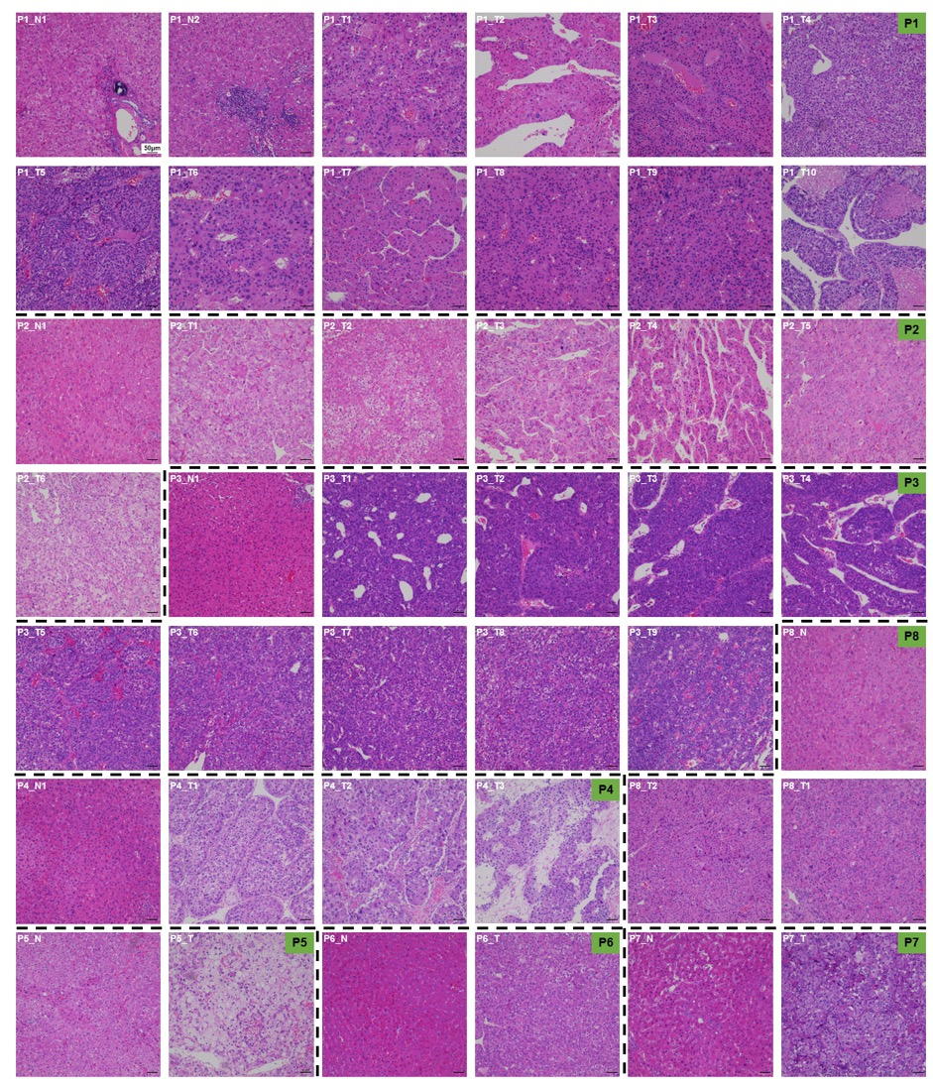
Figure S2 Hematoxylin and eosin staining of the samples used in this study. Images showing the results of hematoxylin and eosin staining of all samples required. Significant heterogeneity of tumor cell morphology was observed by microscopy.

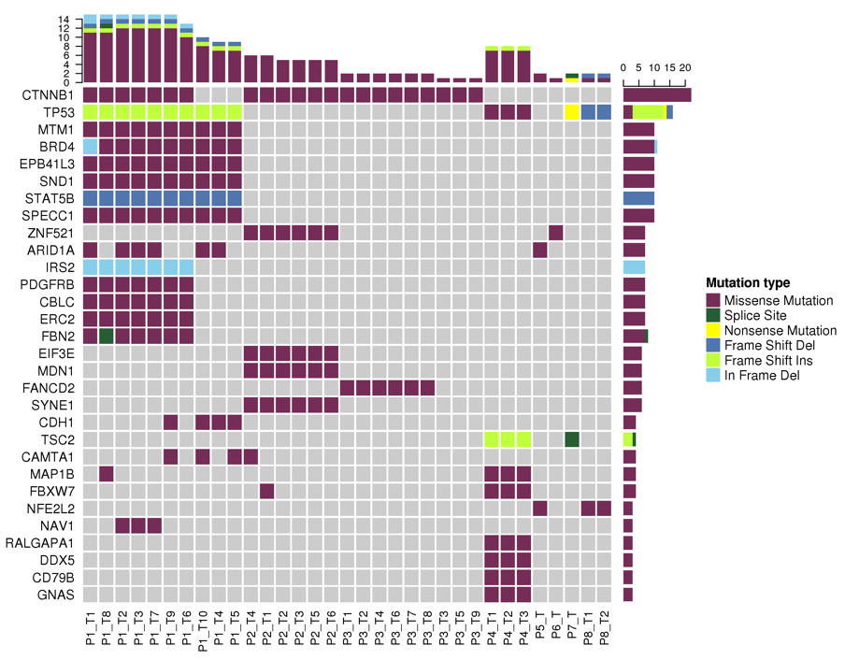
Figure S3 Frequent driver mutations detected in all samples. Part of driver mutations were shown. The full list of all mutations is enclosed in Table S4. Note that certain driver mutations were not found in different lesions of the same tumor.

Figure S4 RNA abundance of six genes. The abundance of RNAs of TP53, CTNNB1, ARID1A, NFE2L2, RB1, and TSC2 was compared between wild-type (WT) and mutant (MT) samples. Statistics was performed using Mann-Whitney U test. *, P < 0.05; ***, P < 0.001.

Figure S5 Mutation spectrum in all HCC lesions. Fraction of each type of nucleotide acid alteration is shown. The fractions vary among tumors/patients and lesions as well.

Figure S6 Heterogeneity of lesions within a tumor in various dimensions (Patient 2). (A) The differences of SNV, INDEL, and driven mutations in all HCC lesions. (B) Frequent driver mutations were shown in each lesion. (C) A phylogenic tree showing the genomic similarity of all HCC lesions. (D and E) Comparison of copy number variations. (F) Comparison of differentially expressed RNAs. Up- and down-regulation as compared to normal tissue. (G) A flower plot showing common and specific differentially expressed RNAs. (H) KEGG pathways differentially expressed RNAs enriched in different lesions. (I) Fusion genes detected in these lesions. (J) A flower plot showing common and specific differentially expressed proteins. (K) A flower plot showing common and specific differentially detected metabolites. (L) Comparison of frequencies of some key types of immune cells in HCC lesions.
Figure S7 Heterogeneity of lesions within a tumor in various dimensions (Patient 3). (A) The differences of SNV, INDEL, and driven mutations in all HCC lesions. (B) Frequent driver mutations were shown in each lesion. (C) A phylogenic tree showing the genomic similarity of all HCC lesions. (D and E) Comparison of copy number variations. (F) Comparison of differentially expressed RNAs. Up- and down-regulation as compared to normal tissue. (G) A flower plot showing common and specific differentially expressed RNAs. (H) KEGG pathways differentially expressed RNAs enriched in different lesions. (I) Fusion genes detected in these lesions. (J) A flower plot showing common and specific differentially expressed proteins. (K) A flower plot showing common and specific differentially detected metabolites. (L) Comparison of frequencies of some key types of immune cells in HCC lesions.

Figure S8 Heterogeneity of lesions within a tumor in various dimensions (Patients 4-8). (A) The differences of SNV, INDEL, and driven mutations in all HCC lesions. (B) Frequent driver mutations were shown in each lesion or tumor. (C) A phylogenic tree showing the genomic similarity of all HCC lesions in Patient 4. (D and E) Comparison of copy number variations. (F) Comparison of differentially expressed RNAs. Up- and down-regulation as compared to normal tissue. (G) A flower plot showing common and specific differentially expressed RNAs. (H) KEGG pathways differentially expressed RNAs enriched in different lesions. (I) Fusion genes detected in these lesions. (J) A flower plot showing common and specific differentially expressed proteins. (K) A flower plot showing common and specific differentially detected metabolites. (L) Comparison of frequencies of some key types of immune cells in HCC lesions.

Figure S9 Hierarchical clustering of differentially expressed mRNA identified from all HCC lesions in patients. The complete linkage method was used for clustering. Significant difference can be found among lesions in the same tumor. Fc > 2.0 or < 0.5, and q < 0.05 were used for screening of differential metabolites.

Figure S10 Comparison of single-cell RNA-seq and bulk RNA-seq of HCCs. Single-cell analysis (microwell-seq) of Patients 1-4 demonstrated significantly heterogeneous HCC cells. A total of 3119, 8150, 5802, and 2554 cells were detected in Patient 1, 2, 3, and 4, respectively. In Patients (A) 1, (B) 2, (C) 3, and (D) 4, HCC cell clusters were manually identified. tSNE plots showing key cell clusters of single-cell sequencing. The 20 most significant genes were screened in each cluster and the screened genes from all clusters were united for reclustering of all single cells (left) and bulk tissue (right). Hierarchical clustering in bulk RNA-seq was performed using the genes of the union set.

Figure S11 Hierarchical clustering of differentially expressed proteins identified from all HCC lesions in patients. The complete linkage method was used for clustering. Significant difference can be found among lesions in the same tumor. Fc > 2.0 or < 0.5, and P < 0.05 were used for screening of differential expressed proteins.

Figure S12 Hierarchical clustering of differential metabolites identified from all HCC lesions in patients. The complete linkage method was used for clustering. Significant difference can be found among lesions in the same tumor. VIP > 1, Fc > 2.0 or < 0.5, and P < 0.05 were used for screening of differential metabolites.

Figure S13 Two-dimensional principle components analysis showed the relationship among lesions in patients in terms of proteome and metabolome. Significant differences can be seen among certain lesions.

Figure S14 Comparison of enriched KEGG pathways in different -omes. Flower plots and veen plots showing enriched KEGG pathways regarding RNAs, proteins, and metabolites among HCC lesions in patients.

Figure S15 Heatmap shows significantly different KEGG pathways based on the enrichment scores. Red boxes indicate synthesis and degradation of ketone bodies (upper) and PI3K-Akt signaling pathway (bottom).

Figure S16 The negative correlations between PI3K-Akt signaling pathway-related proteins and abundance of tumor infiltrating T cells in HCCs. (A) PIK3R2, (B) PDPK1, (C) SGK2, (D) PDK3, (E) AKT1S1, (F) NRAS.

Figure S17 Ketone body metabolism is associated with anti-tumoral immunity in HCC. (A) CD8+ T cell fraction was significantly lower in samples with a high enrichment score of synthesis and degradation of ketone bodies. (B) Scheme showing the key enzymes involved in ketone body metabolism. (C) The negative correlation between OXCT1 expression (data from proteomics) and T cell abundance (data from CyTOF assays). (D) The positive correlation between BDH1 expression and T cell abundance.

Figure S18 Landscape of immune cells in each HCC lesion of patients. tSNE plots showing the heterogeneous immune microenvironment in each lesion of the same tumor.

Figure S19 Correlation of frequency between different cell clusters. Cell clusters that were significantly correlated with (A) Foxp3+ Treg cells, (B) CD4+CD25+Foxp3- cells, (C) PD-L1+ macrophages, (D) PD-L1- macrophages, (E) DCs, (F) PD-1^{high} CD8+ T cells, and (G) Breg cells.

Figure S20 Frequencies of featured clusters in different HCC subtypes. Specific clusters in each HCC subtype are shown. Typically, HCC subtype 1 is featured by abundant functional lymphocytes (nearly all clusters), HCC subtype 2 is characterized by increased myeloid cells (clusters 7, 8, 9, 10, 19), and HCC subtype 3 is represented by increased immunosuppressive cells (clusters 3, 14, 39) and reduced anti-tumoral immune cells (clusters 20, 23, 24). *, P < 0.05; **, P < 0.01; ***, P < 0.001.

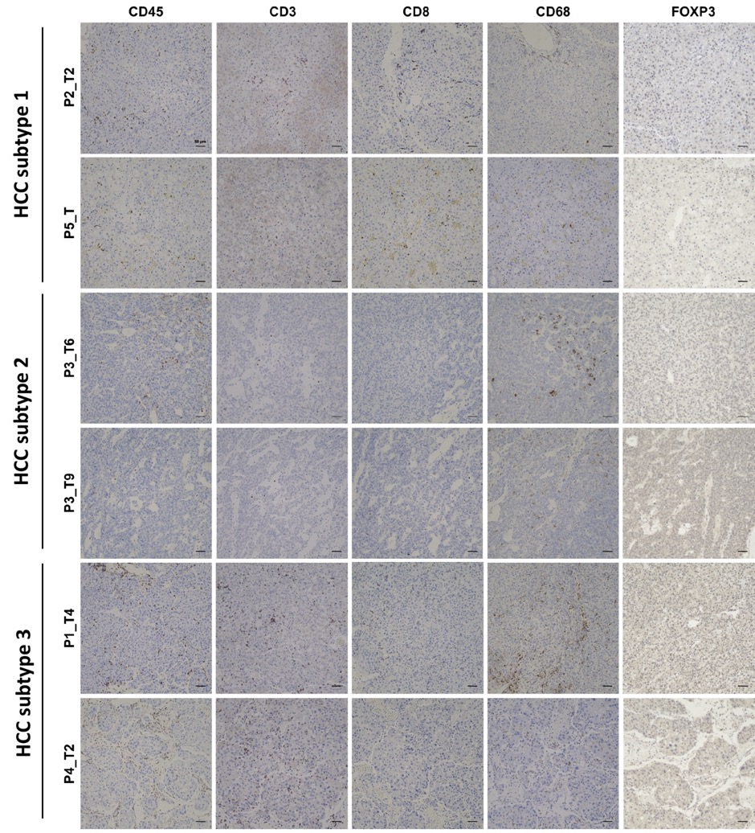
Figure S21 Representative images of immunohistochemistry. CD45, CD3, CD8, CD68 and Foxp3 were stained in representative lesions of the three HCC subtypes to indicate immune cells, total T cells, CD8+ T cells, kuffer cells/macrophages, and Treg cells, respectively.

Figure S22 Expression of key proteins in different HCC subtypes. tSNE plots showing the expression of several critical functional marker genes in the three HCC subtypes and normal tissue. Red boxes indicate identified cell types. Obvious differences can be observed among these HCC subtypes and normal tissue.

Figure S23 Clustering of CyTOF data of 30 HCC samples from an independent cohort. (A) Heatmap showing expression of immune markers in each cluster. (B) Clustering of all 30 HCC samples showed three HCC subtypes as indicated. Red boxes show cell clusters representing anti-tumoral T cells (CD127+ T cells), and the purple box indicates cell clusters expressing Foxp3 (Treg cells and immunosuppressive CD4+ T cells). Green, subtype 1; Blue, subtype 2; Yellow, subtype 3.

Figure S24 Assessment of immunophenotypic classification of HCCs using qPCR. (A and B) The mRNA levels of PTPRC and FOXP3 was positively and negatively correlated with overalls survival of HCC patients. Data derived from a cDNA library containing a cohort of 135 HCC patients. (C) qPCR-based immunophenotypic classification showed potentially different prognoses in HCC patients. *, P < 0.05.

